Ein Bild, das Schwarz, Dunkelheit enthält.

**Master of Applied Information and Data Science**

**Module Data Collection, Integration and Preprocessing**

**Web Scraping of Grocery Pricing: A Comparative Study of Pasta, Rice, and Sauces Across Three Swiss Supermarkets**

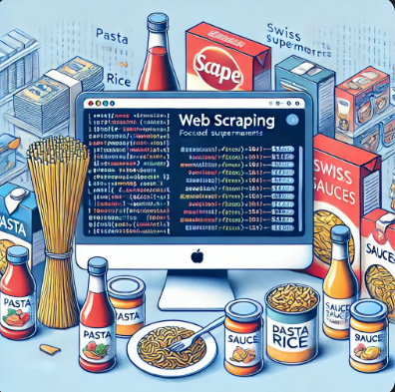

**Group 03**

**Group Members:**

**Fatima Barcina (**[**fatima.barcina@stud.hslu.ch**](mailto:fatima.barcina@stud.hslu.ch)**)**

**Martina Diaz (martina.diaz@stud.hslu.ch)**

**Catalina Roth (catalina.barriosroth@stud.hslu.ch)**

Hand in Date: 15 November 2024

**Table of Contents**

1. Introduction, Motivation, Purpose and Scope 2

2. Research Questions 2

3. Methods 2

3.1 Data Collection (Martina) 2

3.2 Transformation Techniques 3

3.3 Analysis 3

4. Results 3

4.1 Findings 3

4.2 Summary of key Data 3

4.3 Outcomes 3

4.3.1 Competitive Advantage 3

4.3.2 Consumer Benefits 3

4.4 Observations 3

5. Conclusion 3

5.1 Summary About Learning 3

5.2 Limitations 3

5.3 Potential Future Steps to Improve (Cata) 4

# 1. Introduction, Motivation, Purpose and Scope

Recognizing the importance of this Data Collection, Integration and Preprocessing project as future data scientists, we began brainstorming ideas, seeking topics and websites that were of our interest with a practical and real-world focus.

After group evaluation of various proposals, we found a common motivation with clear purpose: analyze market strategies by examining price competitiveness and product diversity in the Swiss retail sector, with the aim of establishing a market comparison. To achieve this, we selected three of the main and popular Swiss supermarkets.

Migros, Switzerland’s largest retail company, stands as the country’s leading supermarket chain. Additionally, it ranks among the forty largest retailers worldwide. Lidl Switzerland AG is a Swiss retail company that operates a nationwide discount store network. As part of the German Lidl Stiftung & Co. KG, Lidl Switzerland is ranked among the 100 largest companies in the country.

This analysis and comparison are based on three basic and essential product categories: rice, pasta, and sauces (tomato and pesto) of the chosen supermarkets.

# 2. Research Questions

The research question that are addressed through the web scraping are:

*1. Which supermarket has the most competitive prices?*

*2. Which competitor offers more brands across distinct categories?*

*3. How much more expensive are own brands compared to traditional brands for each competitor*?

The approach to answering these three main questions and the analysis conducted are detailed in Chapter 3.3 of this report.

# 3. Methods

The methods and techniques for data collection, transformation, and analysis are explained below.

## **3.1 Data Collection (Martina)**

* Description of the web scraping setup and tools (Use of Selenium and Beautiful Soup and Pandas)
* Step for accessing and extracting the Data

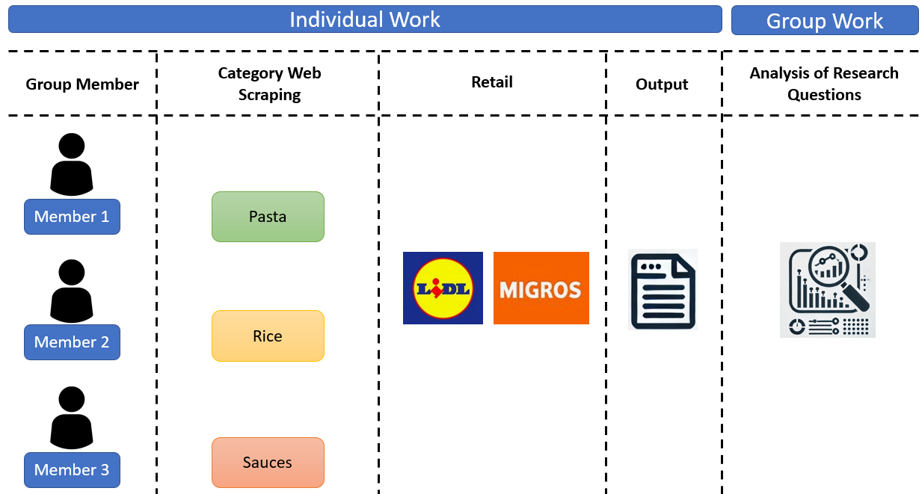

Figure : Work Process

* How is the output looks like?
* Structure of the DataFrame (What we added, calculated, etc)

## **3.2 Transformation Techniques**

* Cleaning, formatting and structure of the scraped data for the analysis (Martina – Cata - Fatima)
* Missing Values (strange things) (Fatima)

## **3.3 Analysis**

* Description of how we addressed each research question
  + How we compared the prices (Average Regular prices – Actual prices) (Fatima)
  + Number of brands per Category (Martina)
  + comparison will be made between traditional brands (e.g., Barilla, Alnatura) and own brands (e.g., Migros Bio, Migros Budget,) to analyze the pricing convenience. (Cata)
* EDA Analysis (Cata)
* Missing values
* Outliers

# 4. Results

## **4.1 Findings**

* Summarize key insights from the data
  + Results of Regular Average Price per category and Competitor -🡪 Plot (Fatima)
  + Brand Diversity per category and Competitor 🡪 Plot (Martina)
  + Gap Price between Private Label and Third Brands 🡪 Plot (Cata)

## **4.2 Summary of key Data**

* Summary of the main key insights of the plots above (Fatima, Martina, Cata )

## **4.3 Outcomes**

### **4.3.1 Competitive Advantage**

* which supermarket appears to offer a more competitive pricings strategies across distinct categories (According Regular Prices and prices with discount)? (Fatima)
* which supermarket offers more brands and how might this attract certain costumers who value more brand options? (Martina)

### **4.3.2 Consumer Benefits**

* Do clients benefit by buying private label brands instead of third brand? How much is the saving? (Cata)

## **4.4 Observations**

* Comment Unexpected Results or notable differences in pricing and variety of brands. (Cata)

# 5. Conclusion

## **5.1 Summary About Learning**

* Skills gained for web scraping and market strategies (Fatima)

## **5.2 Limitations**

* Challenges Faced (Martina)
* Example: We were blocked, finding buttons, cookies messages, etc

## **5.3 Potential Future Steps to Improve** (Cata)

* Suggest Improvements for future studies
  + Expand data to cover other markets
  + Use ML to predict Prices?
  + How can the web scraping improve Marketing campaigns and Pricing strategies?